SUBJECT: CREATIVE ART CLASS: PRIMARY 1
1. Decorative artworks are for decorating ____(a) field (b) house
2. Foot mat and _____are examples of decorative artworks (a) table mat (b) ice-cream
3. Folktale is about ____(a) drama (b) story
4. Primary colours are ________, ______ and _____colour (a) purple , green and orange (b) red, blue and yellow
5. Colour _____, ____ and ______ are secondary colours (a) red, blue and yellow (b) purple, green and orange
6. ___ consists of husband , wife and children (a) school (b) family
7. ___breast feed the baby at home (a) father (b) mother
8. ______ is the head of the family (a) uncle (b) father
9. ______ is to create excitement in a story (a) money (b) song
10. ____must help in washing the plates at home.
(a) children (b) neighbour
SECTION B
1. Draw the following objects at home.
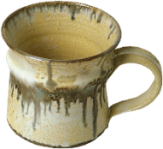
a.

Cup

b.

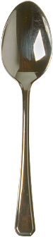
bowl

c.
spoon


d.
knife

2. Draw your hand and beautify it with colour

